**Lab Assignment 03 - To-Do List React Application**

**Components Overview**

**1. App.jsx**

This is the main component of the application that handles the structure and rendering of the to-do list manager.

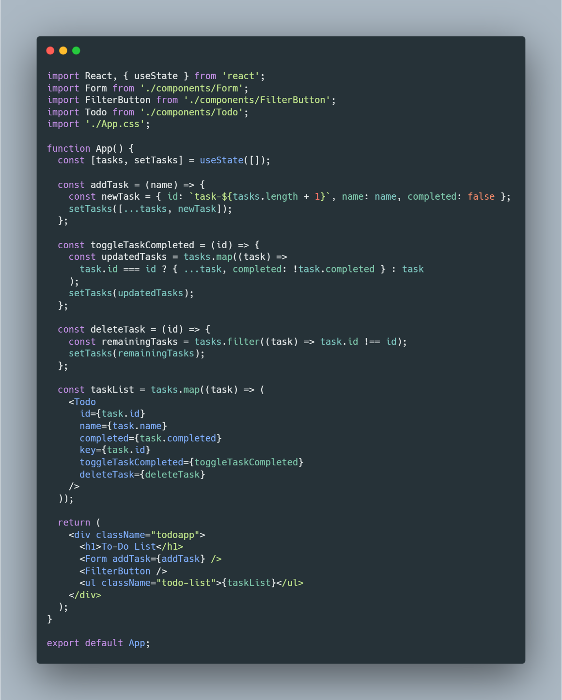

**2. Form.jsx**

Handles input for adding new tasks.

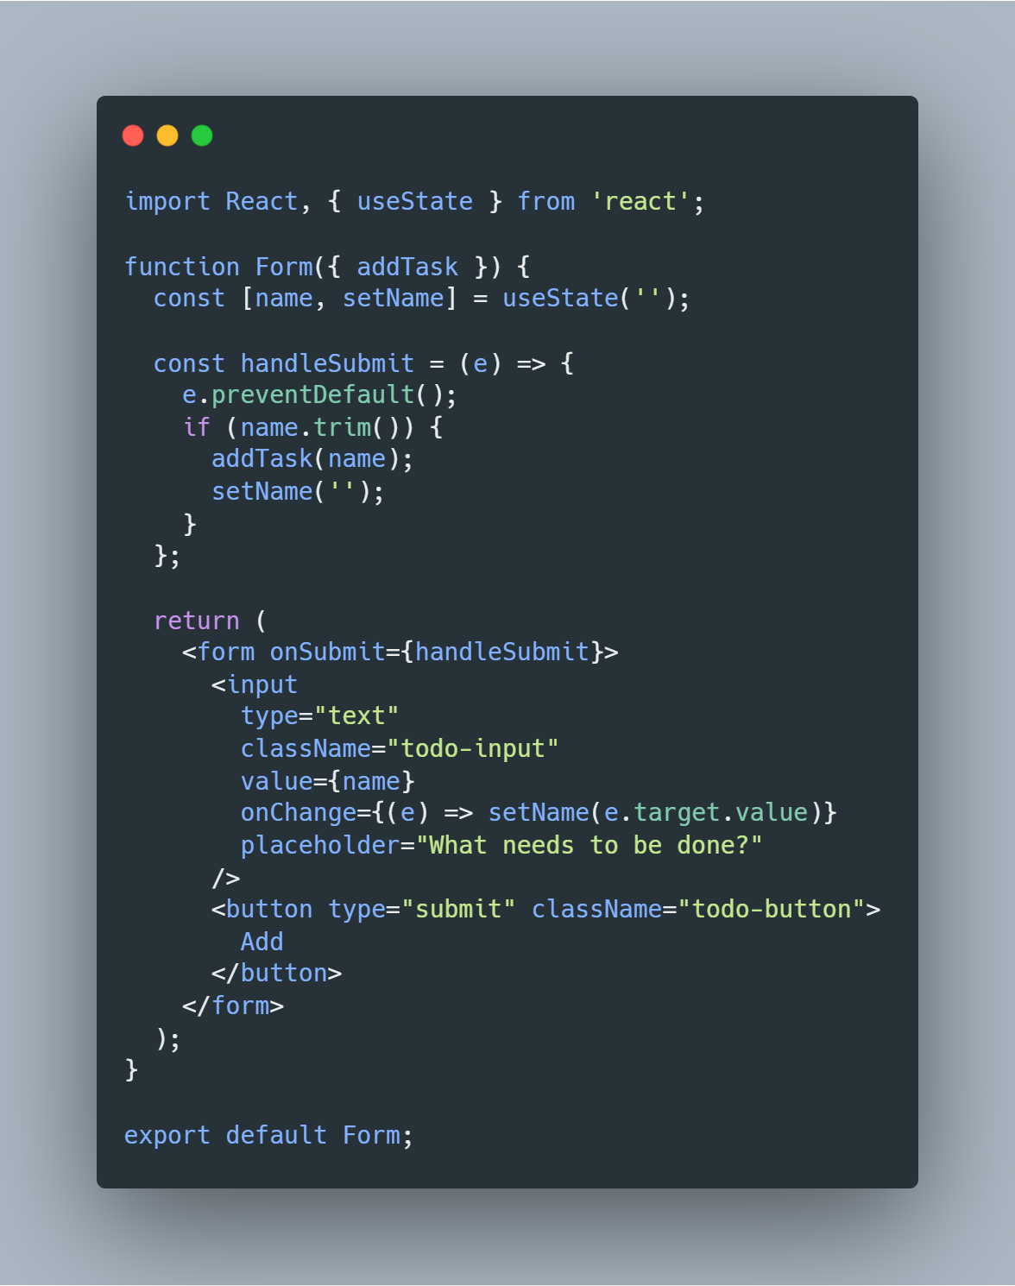

**3. Todo.jsx**

Renders individual tasks with actions.

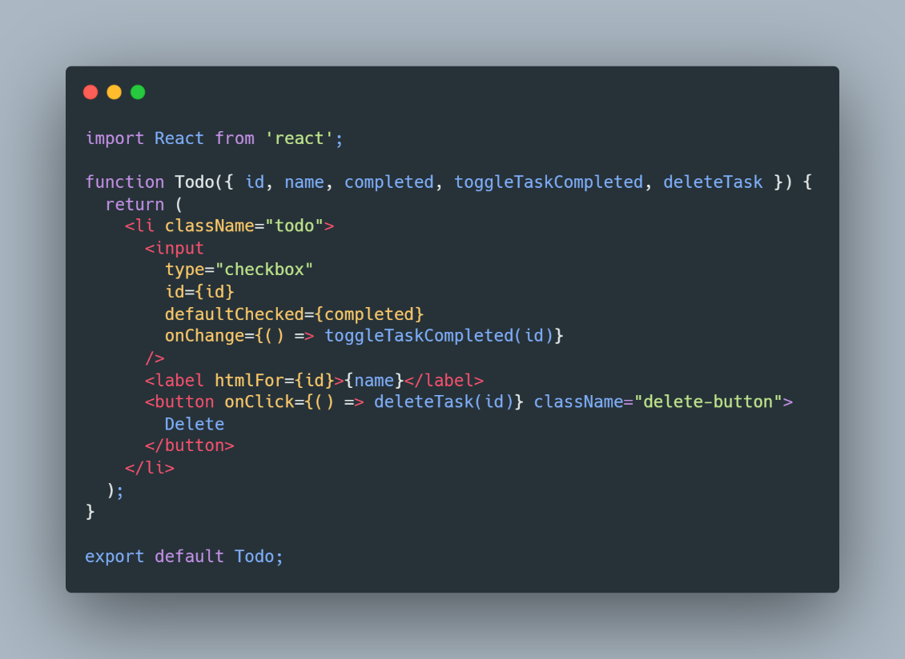

**4. FilterButton.jsx**

Placeholder for filtering tasks (expandable for additional functionality).

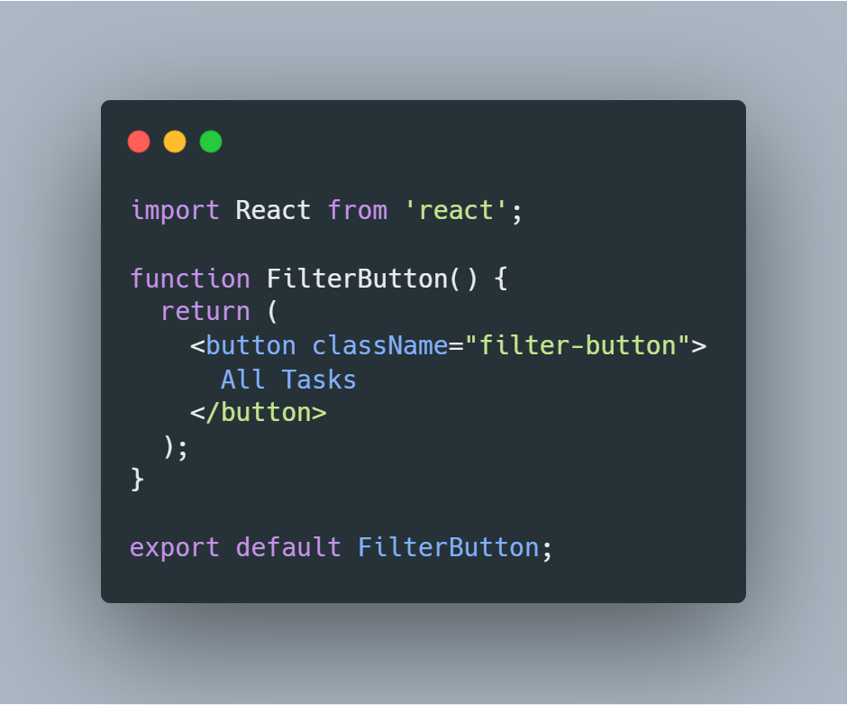

**5. CSS Styling (App.css)**

Defines basic styling for the application.

